**Balanced or Unbalanced Chemical Equation Practice**

|  |
| --- |
| UNBALANCED EQUATION  BALANCED EQUATION |
| BALANCED EQUATION  UNBALANCED EQUATION |
| BALANCED EQUATION  UNBALANCED EQUATION |

|  |
| --- |
| A black arrow pointing to the left  Description automatically generated  BALANCED EQUATION  UNBALANCED EQUATION |
| BALANCED EQUATION  UNBALANCED EQUATION |
| A black arrow pointing to the right  Description automatically generated  UNBALANCED EQUATION  BALANCED EQUATION |

Now try the rest!





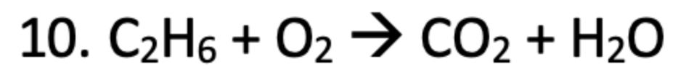

Now try some with coefficients.



What if there are parenthesis? What do I do? Let’s practice!



1. Practice the rest on your own:

1. Practice these with coefficients and parenthesis:

